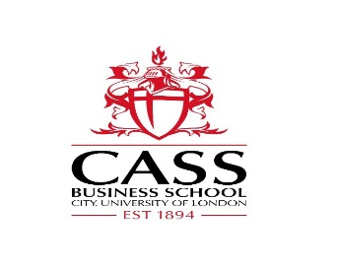

**APPLIED RESEARCH PROJECT –** SAVVY DATA INSIGHTS Project 2

|  |
| --- |
| **KEY FACTS ABOUT THE INDUSTRY PARTNER**  Concise description of the business: Savvy Data Insights is a consulting company that uses an innovative approach which combines the expert knowledge of business users with insights extracted by data analysis algorithms. |

|  |
| --- |
| **PROJECT SPECIFICATION**  Succinct background: Market basket analysis aims to extract products/services that are commonly bought together. This information helps companies understand the role of particular products, e.g. complementary products. It can then be used to influence marketing and sales strategies.  Task: Comparing traditional market basket analysis techniques with network science techniques.  Key aims: Model customer transactions as a network and extract groups of commonly bought together products as well as important products using Network Science metrics.  Desirable skills: Machine Learning and Network Modelling skills would help to experiment the proposed methodologies.  Required dataset: Records of clients transactions of products/services of a particular company. |

|  |
| --- |
| **KEY FACTS ABOUT CASS BUSINESS SCHOOL**  Contact persons: Dr Oben Ceryan ([Oben.Ceryan@city.ac.uk](mailto:Oben.Ceryan@city.ac.uk)), Dr Pedro Rodrigues, SAVVY DATA INSIGHTS ([pedro@savvydatainsights.co.uk](mailto:pedro@savvydatainsights.co.uk)) and Dr Simone Santoni (Simone.Santoni.1@city.ac.uk). |

|  |
| --- |
| **PROJECT EXECUTION**  Student(s) – depending on the size of the project and students’ preferences, each project could be assigned to one or more students. Each project is solely chosen by each student *before 17th of February, 2019*. Specific project goals and understanding the industry partner’s business are set in between the student(s) and designated contact person *before 31st of March, 2019*.  Actual execution of the project – starts *no later than the beginning of May 2019* after the exam period that ends on *3rd of May, 2019*.  Deliverable and other direct outputs – the mandatory academic task of each student is to produce a *3,000 to 5,000 words document by 31st of August, 2019* that aims to assess the academic attainments, appropriate communication of results with no evidence of poor scholarship and plagiarism. The summary report of the project outcomes are only delivered to the industry partner *by 30th of September, 2019, but further developments are possible if the industry partner and the student(s) agree to do so.*  Notes: All parties have no financial obligation to each other and the industry partner is entitled to sign a confidentiality agreement with the student(s) involved with the project execution. |

Version: 1.0

Version date: June 2018

For use from: June 2018